**BANK LOAN REPORT QUERY DOCUMENT**

1. **BANK LOAN REPORT | SUMMARY**

**KPI’s:**

**Total Loan Applications**

Select COUNT(id) AS Total_Loan_Applications

from loan_data;

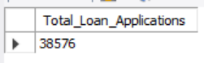

**MTD loan applications:**

SELECT COUNT(id) AS Total_Applications FROM loan_data

WHERE MONTH(issue_date) IN (SELECT MAX(MONTH(issue_date)) from loan_data)

AND YEAR(issue_date) IN (SELECT MAX(YEAR(issue_date)) from loan_data)

;



**PMTD loan applications:**

SELECT COUNT(id) as PMTD_loan_applications

from loan_data

Where MONTH(issue_date)= 11 AND YEAR(issue_date) =2021

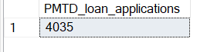

**Total Funded Amount:**

Select SUM(loan_amount) as Total_funded_amount

from loan_data

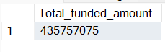

**MTD funded amount:**

Select SUM(loan_amount) as Total_funded_amount

from loan_data

WHERE MONTH(issue_date) IN (

SELECT MAX(MONTH(issue_date))

from loan_data) AND YEAR(issue_date) IN

(

SELECT MAX(YEAR(issue_date))

from loan_data

);

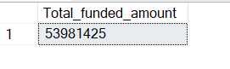

**PMTD funded amount:**

Select SUM(loan_amount) as Total_funded_amount

from loan_data

WHERE MONTH(issue_date) IN (

SELECT (MAX(MONTH(issue_date))-1)

from loan_data) AND YEAR(issue_date) IN

(

SELECT MAX(YEAR(issue_date))

from loan_data

);



**Total amount received:**

Select SUM(total_payment) as Total_amount_received

from loan_data

**MTD Total amount received**

Select SUM(total_payment) as mtd_Total_funded_amount

from loan_data

WHERE MONTH(issue_date) IN (

SELECT MAX(MONTH(issue_date))

from loan_data) AND YEAR(issue_date) IN

(

SELECT MAX(YEAR(issue_date))

from loan_data

);



**PMTD Total amount received:**

Select SUM(total_payment) as PMTD_Total_funded_amount

from loan_data

WHERE MONTH(issue_date) IN (

SELECT (MAX(MONTH(issue_date))-1)

from loan_data) AND YEAR(issue_date) IN

(

SELECT MAX(YEAR(issue_date))

from loan_data

);

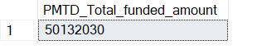

**Average Interest Rate:**

SELECT ROUND(AVG(int_rate) * 100,2) as Avg_interest_rate

From loan_data

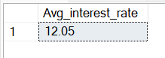

**MTD Average Interest Rate:**

SELECT ROUND(AVG(int_rate) * 100,2) as MTD_Avg_interest_rate

From loan_data

WHERE MONTH(issue_date) IN (

SELECT MAX(MONTH(issue_date))

from loan_data) AND YEAR(issue_date) IN

(

SELECT MAX(YEAR(issue_date))

from loan_data

);

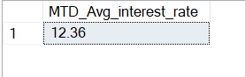

**PMTD Average Interest Rate:**

SELECT ROUND(AVG(int_rate) * 100,2) as MTD_Avg_interest_rate

From loan_data

WHERE MONTH(issue_date) IN (

SELECT (MAX(MONTH(issue_date))-1)

from loan_data) AND YEAR(issue_date) IN

(

SELECT MAX(YEAR(issue_date))

from loan_data

);



**Average DTI:**

SELECT ROUND(AVG(dti)*100,2) as Avg_dti

from loan_data

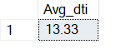

**MTD Average Interest Rate:**

SELECT ROUND(AVG(dti) * 100,2) as MTD_Avg_dti

From loan_data

WHERE MONTH(issue_date) IN (

SELECT MAX(MONTH(issue_date))

from loan_data) AND YEAR(issue_date) IN

(

SELECT MAX(YEAR(issue_date))

from loan_data

);



**PMTD Average Interest Rate:**

SELECT ROUND(AVG(dti) * 100,2) as PMTD_Avg_dti

From loan_data

WHERE MONTH(issue_date) IN (

SELECT (MAX(MONTH(issue_date))-1)

from loan_data) AND YEAR(issue_date) IN

(

SELECT MAX(YEAR(issue_date))

from loan_data

);



**GOOD LOAN:-**

**Good loan percentage:**

SELECT

(COUNT(CASE WHEN loan_status='Current' OR loan_status='Fully Paid'

THEN id

END) * 100 )/ COUNT(id)

as Good_loan_percentage

from loan_data

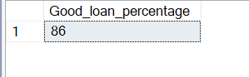

**Good loan applications:**

SELECT COUNT(id)

as Good_loan_applications

from loan_data

where loan_status in ('Current','Fully Paid')

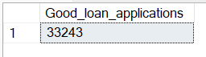

**Good loan total funded amount:**

SELECT SUM(loan_amount)

as Good_loan_funded_amount

from loan_data

where loan_status in ('Current','Fully Paid')

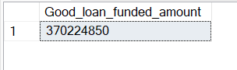

**Good loan total received amount:**

SELECT SUM(total_payment)

as Good_loan_payment_received

from loan_data

where loan_status in ('Current','Fully Paid')

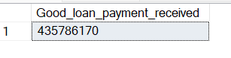

**BAD LOAN ISSUED:**

**Bad loan percentage: -**

SELECT

(COUNT(CASE WHEN loan_status='Charged Off'

THEN id

END) * 100 )/ COUNT(id)

as Bad_loan_percentage

from loan_data



**Bad loan applications: -**

SELECT COUNT(id)

as Bad_loan_applications

from loan_data

where loan_status in ('Charged Off')



**Bad loan total funded amount: -**

SELECT SUM(loan_amount)

as Bad_loan_funded_amount

from loan_data

where loan_status in ('Charged Off')

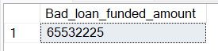

**Bad loan total received amount: -**

SELECT SUM(total_payment)

as Bad_loan_payment_received

from loan_data

where loan_status in ('Charged Off')



**LOAN STATUS:**

Select loan_status,

COUNT(id) as Loan_applications,

SUM(total_payment) as Total_amount_received,

SUM(loan_amount) as Total_funded_amount,

ROUND(AVG(int_rate)*100,2) as Interest_rate,

ROUND(AVG(dti) * 100,2) as DTI

from loan_data

GROUP BY loan_status

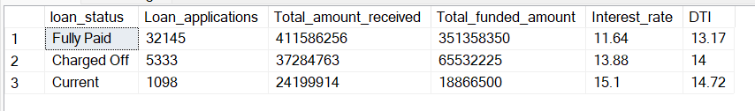

Select loan_status,

SUM(total_payment) as MTD_Total_amount_received,

SUM(loan_amount) as MTD_Total_funded_amount

from loan_data

WHERE MONTH(issue_date) IN (

SELECT MAX(MONTH(issue_date))

from loan_data) AND YEAR(issue_date) IN

(

SELECT MAX(YEAR(issue_date))

from loan_data

)

GROUP BY loan_status

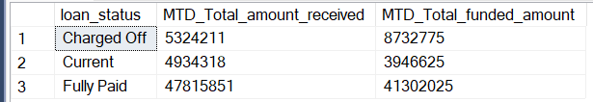

**BANK LOAN REPORT | OVERVIEW**

**MONTH**

SELECT

MONTH(issue_date) AS Month_Munber,

DATENAME(MONTH, issue_date) AS Month_name,

COUNT(id) AS Total_Loan_Applications,

SUM(loan_amount) AS Total_Funded_Amount,

SUM(total_payment) AS Total_Amount_Received

FROM bank_loan_data

GROUP BY MONTH(issue_date), DATENAME(MONTH, issue_date)

ORDER BY MONTH(issue_date)

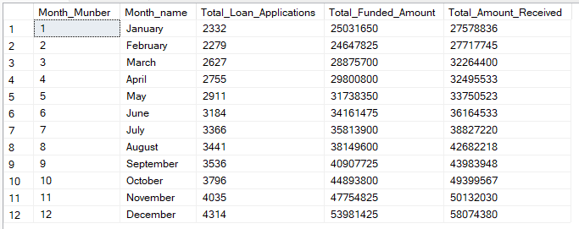

**STATE**

SELECT

address_state AS State,

COUNT(id) AS Total_Loan_Applications,

SUM(loan_amount) AS Total_Funded_Amount,

SUM(total_payment) AS Total_Amount_Received

FROM bank_loan_data

GROUP BY address_state

ORDER BY address_state

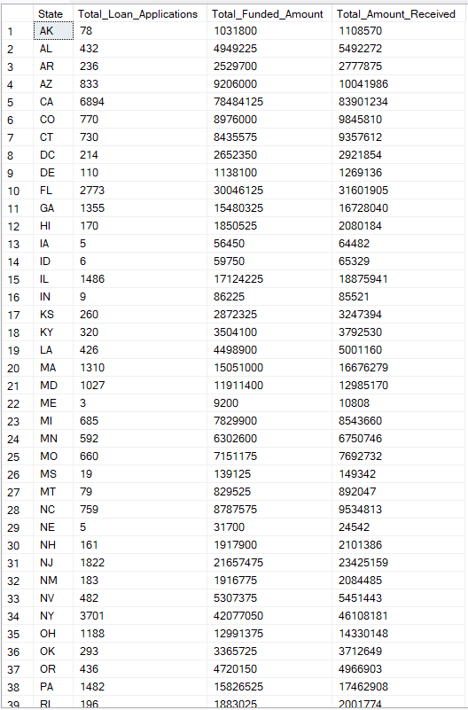

**TERM**

SELECT

term AS Term,

COUNT(id) AS Total_Loan_Applications,

SUM(loan_amount) AS Total_Funded_Amount,

SUM(total_payment) AS Total_Amount_Received

FROM bank_loan_data

GROUP BY term

ORDER BY term

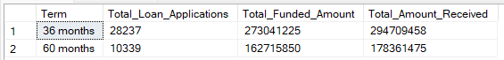

**EMPLOYEE LENGTH**

SELECT

emp_length AS Employee_Length,

COUNT(id) AS Total_Loan_Applications,

SUM(loan_amount) AS Total_Funded_Amount,

SUM(total_payment) AS Total_Amount_Received

FROM bank_loan_data

GROUP BY emp_length

ORDER BY emp_length

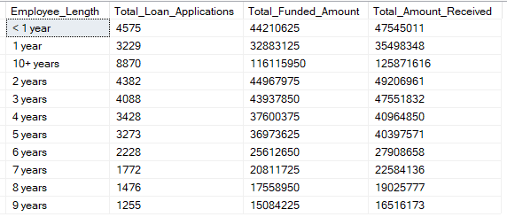

**PURPOSE**

SELECT

purpose AS PURPOSE,

COUNT(id) AS Total_Loan_Applications,

SUM(loan_amount) AS Total_Funded_Amount,

SUM(total_payment) AS Total_Amount_Received

FROM bank_loan_data

GROUP BY purpose

ORDER BY purpose

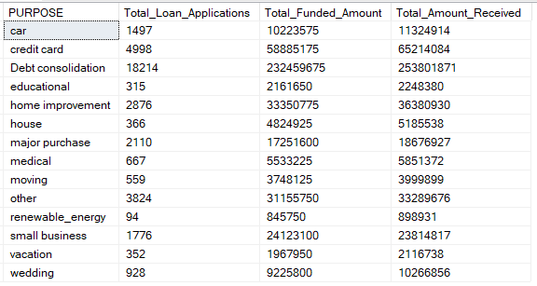

**HOME OWNERSHIP**

SELECT

home_ownership AS Home_Ownership,

COUNT(id) AS Total_Loan_Applications,

SUM(loan_amount) AS Total_Funded_Amount,

SUM(total_payment) AS Total_Amount_Received

FROM bank_loan_data

GROUP BY home_ownership

ORDER BY home_ownership

